|  |
| --- |
| 1.Develop a Student registration form using HTML Form elements. (Assume your own fields).  <https://www.roseindia.net/html/how-to-create-student-registration-form-with-html-code.shtml>  (we can use this also ).  OR |

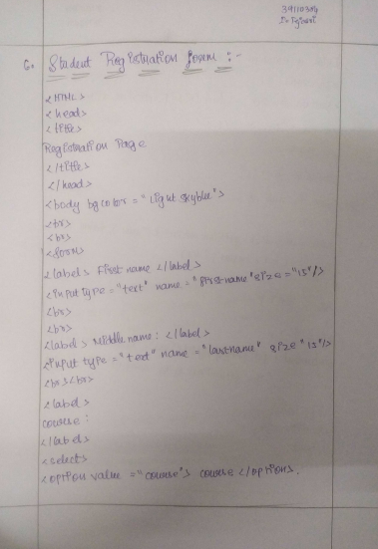

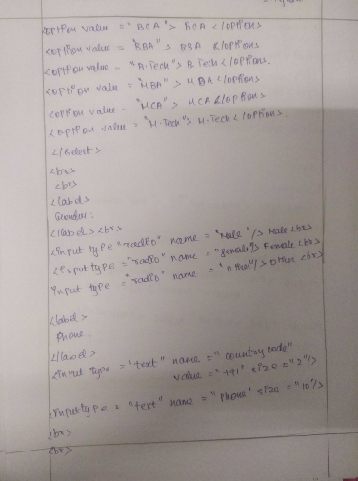

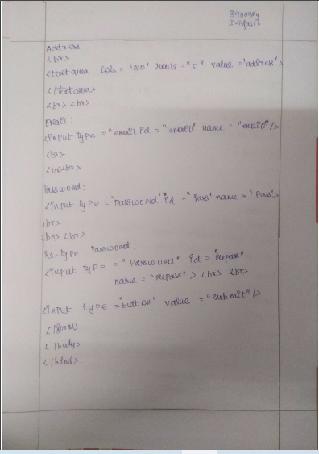

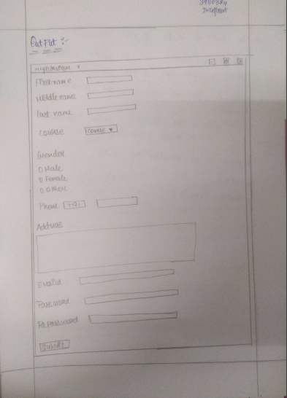

.

|  |
| --- |
| 2.Classify the various types of style sheets. Briefly explain about linking of external Style sheets and fixing the backgrounds. |

<http://www.landofcode.com/css-tutorials/css-stylesheets.php>

<https://www.tutorialspoint.com/linking-external-style-sheets-in-css>

<https://www.tutorialspoint.com/html/html_style_sheet.htm>

|  |
| --- |
| 3.State the uses of function. Develop a program in java script to calculate factorial using function.  <https://www.javatpoint.com/how-to-find-factorial-of-a-number-in-javascript> |

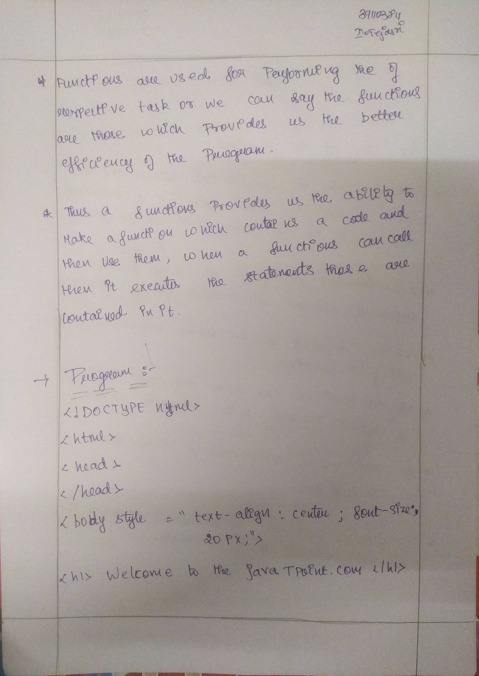



|  |
| --- |
| 4.Summarize the methods associated with array object in JavaScript. Explain any two methods with an example.  <http://www.tutorialspark.com/javascript/JavaScript_Array_Object_Methods.php>  (every thing is here). |
| <html>  <body>  <script>  var i;  var emp = new Array();  emp[0] = "Arun";  emp[1] = "Varun";  emp[2] = "John";    for (i=0;i<emp.length;i++){  document.write(emp[i] + "<br>");  }  </script>  </body>  </html> |
|  |

